Week 7

Product

Learning objective
- Identify classifications of products. Identify the four characteristics of services.
- Identify product and service elements.
- Outline steps in developing new product.
- Understand a product life cycle, and what marketers should do in each stage of a life cycle

1. What is product and service?
The objective of this topic is to be able to define and classify the product in order to understand target group and the limitation of the product.
Product can be in any form such as physical goods, services, events, organization, ideas, and persons that can be served to the market to satisfy a need or solve the problems of customers.
- Product is tangible thing that can be offered to the market to satisfy customers’ need such as shampoo and TV. This is required low involvement and low quality control problems. It is easy for firms to evaluate. But it is required inventory to stock products. There is no time criteria after possession. There is low importance of contact point which makes firms do not keep observe providers’ satisfaction.
- Service is intangible and does not result in the ownership of anything such as hair cut, financial advice. It is high involvement and high quality control problems. It is hard for firms to evaluate. There is a strict time criteria. For example, customer cannot own the hotel; there is a book time. The high importance of contact point is required as firms have to keep make sure service providers’ satisfaction.
Nowadays, many firms convert service and product together. For example, Nestle sells water as a product and also has a delivery as a service. Hair salon is a service but some salons also sell goods like shampoo, treatment.

2. Product classification
There are 3 criterias to classify the product depending on the purpose of the product
2.1 Durability
Durability can be divided in two goods which are nondurable goods and durable goods. Nondurable goods is that the product’s life is short; less than 3 years such as shampoo and food. For durable goods, it is last long product usually more than 3 years such as clothing, TV, and fridge.
2.2 Tangibility
Tangibility can be groups into two groups which are tangible goods and intangible goods. Tangible goods that result in ownership after purchasing such as soap and mobile phone. Intangible goods is a service, so people cannot own anything after paying such as education advice and appliance repair.
2.3 Frequency of use/ characteristics
Characteristics of goods can be classified in 4 groups as follows.
1. Convenience Goods
The products that is offered in low price and placed in many purchase locations. It is something that customers buy routinely including staple goods (regularly buy), impulse good (do not plan to buy before), emergency goods (have to use in that moment, sanitary goods). Customers do not compare products. Mass promotion by producer is required.
2. Shopping Goods
The products with higher price, not often buy, located in fewer purchase locations. It require time to gather information, much planning. Customers have to compare brands between suitability and quality, price and style such as airplane flight,computer, furniture. Advertising and personal selling by both producer and resellers is required.
3. Specialty Goods
The product with high price and have unique characteristics. The products present brand identification and are placed in few purchase locations. It involves image and brand building. Personalized services is required in order to build trust and relationship with customers. It emphasize on strong brand preference and loyalty. Customers have little brand comparison and low price sensitive. It require more carefully targeted promotion For example, Mercedes-Benz, Botox injection
4. Unsought Goods
It is the products that consumers do not want to think about it such as Slim up center, Pre-need funeral plans, and insurance. Therefore, it is required aggressive advertising and personal selling. Price and distribution are various.

3. Level of Product
There are 3 levels of product and services including core product, actual product and augmented product.
- Core product is basic benefits. For example, mobile; calling, taking a photo, and having games
- Actual product is about features, package, brand, quality, appearance that distinguish one brand from others, such as color, body size, model name, and interior design.
- Augmented product is after-sale service like warranty, repair, installation, customer support services, delivery, credit, and product-use instruction.

4. Product Elements (Market’s decision)
Objective
After firms classify their products, It is important for marketers to describe the decision that the companies make regarding their products and services, product lines, and product mixes.
There are 4 main elements which are product attributes, branding, packaging, and support service.
4.1 Product attributes (benefit) is an “Actual product”. It contains 3 parts: quality, feature, and style and design.
- Quality
It directly impacts on product performance. Product should be no defect, and in a term of customer-centered meaning, “the quality is when customers come back, not our products”. The quality has two dimensions
- Level (performance)
It is ability to perform its function, and the quality level should match with target customers.
- Consistency (conformance)
Product should be free from defect and has consistency in delivering a targeted level of performance.
- Features
A part that distinguish the product from other companies, and a distinct part that supplements the basic functions. It can be divided into 2 features
- Primary Features involves size, material, shape, and color.
- Extra Features involves environmental friendly, and the feature that suit with customers’ personality.
- Style and Design
Style is appearance and design is appearance plus usefulness. Design is required observation of customers’ need and develop a deep understand to satisfy their need.

4.2 Branding is an “Actual product”. Brand is not just a name but also a term, sign, symbol, or design or a combination of these that identify the marker or seller of a product and service. Brand add value to the product. Consumers attach to the brand and develop the relationship with brand. It also provides legal protection for unique feature which allows firms to have competitive advantages. It also helps firms to segment markets and provides carryover effect. Branding can be a Brand name, Brand mark, or Trademark.

4.3 Packaging and Labeling is an “Actual product”.
- Packaging
There are several functions of packaging.
- Protection is a primary function It is against damage, spoilage and pilferage.
- Preserving quality is to maintain original taste or feature.
- Convenience is to help customer easy to open and support product usage.
- Serving different needs and occasions is to serve different size and shape to match people.
- Attention is to promote products. Different appearance lets people play around the product
- Recycling can reduce waste
2. Labeling
Label tell the product’s information brand name, symbol, ingredient, nutrition facts, weight, instructions, manufacturing and expiry date, name and address of the manufacturer and distributor. It can promote product through label and brand logo. Firms must be aware of labeling error (must be accurate); for example, name does not match with ingredients or different versions of labels do not match (language).

4.4 Support services is an “Augmented product”.
- Credit and financing should be provide for high priced product to customers to pay by installments.
- Warranty should be provided for durable goods and electronic products to make sure that product is usable in the certain period of time. Firms have to state the condition whether limited or extended, domestic or international. It must be stated clearly for warranty such as replace, repair or money-back.
- Delivery is physical movement to delivery the products to customers. It can be free delivery with high-priced items or mmall charge with low-priced items.
- Installation and training is suitable for complex and technical products. It can be One-off or regular maintenance.
- Customer services provide information and coordination assistance. This service can provide pass through channel (online or offline) or duration (24/7 or business hours).

5. Level of service

It is a acts, efforts, and performances the deliver from the producer to user without any ownership rights.

6. Service Marketing (elements)
The objective is to identify four characteristics that affect marketing of services and additional considerations that is needed for service marketing.
6.1 Intangibility
Services cannot be seen, tasted, felt, heard, or smelled before purchase. It is hard to evaluate before you use. Therefore, make it tangible as much as possible to send the right signal of quality. For example, give free trial, decorate environment by adding tangible thing to make customers feel the right track.
6.2 Inconsistency (variability)
It can be inconsistency in terms of standardize, select and train employees, reliable equipment, IT. Quality depends on providers, when, where, and how. Company try to make sure that it maintain standard.

6.3 Inseparability
Services cannot be separated from service providers. Therefore, firms have to emphasize employee role; responsive, empathetic, competent. Make sure that staff have knowledge and service mind.

6.4 Inventory (Perishability)
Services cannot be stored for later sale. Sometimes, demand is fluctuated; therefore, firms have to come up with promotion in low season, use part-time and multi-skilling staffs, advance reservation, and comfortable waiting area.

For service, there is internal and external marketing. Internal marketing is that firms have to provide employees’ knowledge and involvement and make sure employee satisfaction. External marketing is about customers. Firms have to evaluate customers’ value and satisfaction in order to create customer loyalty.

Product evaluation exercise
Students are asked to choose 1 product and 1 service, and are to evaluate product/service (see the Appendixes for examples of Samsung/Starbucks)
- First, list key elements of the product/service they choose
- Second, identify criteria that can be used to evaluate each element
- Third, give a rating on each criterion and provide explanations on your rating
- Fourth, identify unique selling point of the chosen brand
- Fifth, identify product’s primary features and propose extra features

7. Product-related decision
7.1 Product extension decision (product line and mix)
Product line is a group of products that are closely related in terms of function, target group, and channel. Objective is to grow, compete the line to enhance market position, enhance optimal use of resources; make all equipment and area fully utilize and protect against economic swings. Product line decision depends on company objectives. For length, if the company wants to gain market share then the length should be long. But if they want to focus on profit the length should be short. Firms can expand product line in 2 ways; product line filling (similar price range) and product line stretching (various price and quality)
For product mix decision,
- Product mix “width” is referred to the number of product lines that firm offer.
- Product mix “Length” is referred to the number of items within its product line.
- Product mix “Depth” is referred to the number of versions offer in each product line.

7.2 Product deletion decision
There are many reasons, that firm decides to eliminate some product lines in order to improve marketing strategy. Deletion product can be involved preservation limited resources or shortage of raw materials. Moreover, the product is not fit into the firm’s direction or is unprofitable products, so firm needs to delete them.

8. Product development process and life cycle
Firms always come up with the new product to attract the market and gain market share. Therefore, they launch product that the company and customers has not handled before. For example, product replacement ( new version of existing product), additional to existing line (existing line with new segment), new-to-the world product (never have before), new product lines (firm never produce before)
The ways firm can obtain new products are acquisition and new product development. Acquisition is when firm buy a whole company, patent, and license to produce someone else’s product. For new product development, it refers to original products, product improvements, product modifications, and new brand developed from the firm’s own research.
The objective to learn product development process and life cycle are to extend product life-cycle, preempt competition, meet financial, operational, and marketing objectives. As the world has changed, firms have to responds to market changes, build an innovative image and secure your position and earn higher revenue.

8.1 New product development process
The objective is to be able to explain how companies find and develop new product ideas. Also, marketers must list and define the steps in the new product development process and how to manage each step properly.
There are six steps in new product development process.
Step 1: Idea generating
Idea generating can come from internal sources such as CEO, employee, or product development team or external sources,a source outside the company, such as customers, crowdsourcing( a broad communities of people), foreign market, suppliers or retailers.
Firms must encourage employees to come up with the new idea by welcoming idea sharing, not criticizing, creating conducive environment, giving incentives, or explosing to new experiences.

Idea generation exercise
*Instructor has a few exercises to build creativity skills
1. students are asked to come up with a list of ‘white’ things that one can eat as many as possible
2. students are presented with a list of products, and are asked to try combine these products to create a new product since several new products come from combinations of current products
3. students are presented with an everyday object like spoon, chair, fan, paper clip, and are asked to think of as many uses of that product as many as possible

Step 2: Idea screening
After collecting some ideas, firm must identify which is good ideas and drop off poor ideas. Firm have to evaluate possibility (is it real?), opportunity (can we win?), cost (is it worth doing?). There are many dimensions that firm have to think about such as profit, image, resource, timing, budget, and customer.

Step 3: Business analysis
Company need to analyze any possible scenarios in terms of sale, growth rate, potential market, cost of production, marketing, resources, investment, profitability.
Concept testing is necessary in analysis step. Firm have to develop concept to suit with targeted customers and market. Moreover, consumer testing is required in order to understand concept understanding and belief of customer through product. Marketers are able to evaluate attention and perception of customers about new product idea, receiving attribute importance rating, knowing expected price.
After done business analysis and concept testing, firm is able to define target market and need; also determine financial and technical requirement

Step 4: Product development

Product development is when firm converting product concept into physical product to ensure that the product idea can be turned into a workable market offering.
- Laboratory R&D team is to design the actual offering and determine specifications or develop prototypes (an early sample, model) and test prototypes. It also involves packaging, and other elements in the mix can be similarly studied.
- Manufacturing process is that distinction between what an engineer assemble in a laboratory and what a factory worker can produce. It undertake the manufacturing-method research to plan the best way of making the product in commercial quantities
- Product testing (with customers) is to sample of people test products in an actual use environment in days, weeks, months.
Step 5: Test marketing
This is the stage of new product development in which the product and its proposed marketing program are tested in realistic market setting. It is beneficial for company to assess workability of product and marketing plan.. Also, firm will be able to estimate sale volume and market share. However, there is a risk about substantial cost (production, marketing). Firm may lost some customers due to testing of inferior product. Another risk is the information leakage to competitors.

Step 6: Commercialization
Involving introducing a new product into the market. Firm mostly evaluate 90 days. The commercialization is important to gain public attention and high risk fail. There are many elements that firms lead company to the failure of commercialization therefore, firm have to consider before launching commercial including timing, overstating commercial, lack of customer empathy, requiring education for customer, poor match for capability, small market, or huge expense.

8.2 Consumer Adoption Process and Curve
This would help companies to understand the adoption and diffusion process of new product. If companies understand this process and how it works, companies would be able to design their products and advertisement to suit each stage to gain more attention.
The buyer decision process for new products consists of 5 stages.
Consumer adoption stages
Stage 1: Awareness
In this stage, consumers become aware of product available in the market. They may see in advertising, billboard, or supermarket shelf.
Stage 2: Interest
The buyers search for information about interesting product. Buyers know more and learn about the product and purpose that satisfy their needs.
Stage 3: Evaluation
Buyers weight the benefits and drawbacks of the product and decide whether to try product or not.
Stage 4: Trial
This stage is when buyers try or examine products and see the result that is it meet their needs or not.
Stage 5: Adoption
Buyers decide to purchase the product and be expected that they will buy the product again if their need for this type of product arise again.
Consumer adoption curve
The objective of learning this is to help firms identify the characteristics of their customers in each stage. And help firms to reach their customers more by giving products to the influence group that their comments would affects other groups of consumers.
- Innovators is a group of people who take risk to try the product first (venturemore). Mostly they are higher educated. They research from multiple information sources before purchasing.
- Early Adopters a group of leading society trend. A very first group who try the product and review the product which their opinion can influence society to follow them. They acts as test market and evaluate the product. They are usually young, high educated and receiving high income.
- Early Majority is a group that wait review from early adopters as an additional information and rely on those experiences. They are deliberated (wait and seek for information until sure about the product)
- Late Majority who usually are below average social status.
- Laggards people are fear of debt when they decide to purchase some things that are valuable and high price. Their sources of information are their neighbours and friends.

Product characteristics influencing adoption rate
- Relative advantage: the product with innovation that are far superior to existing substitutes but come with low price, easy to use, lighter, and faster.
- Observability/ communicability: it is the product that consumer can observe the attributes and benefits. For example, the product that has review on Youtube or in-store demonstration.
- Compatibility: Innovation that fit or is consistent with current need, value, lifestyle, practices, existing products such as senior food, contraceptives and religious beliefs.
- Complexity: The product which is relatively difficult to understand and used innovation to influence the speed of acceptance. For example, Google Glass
- Possibility of trail use/ Trialability/ Divisibility: A product that offer a free trail on a limited basis. Trial will reduce the financial and physical risk, therefore customers will be willing to buy more. For example, trial size, free trials, free samples, discounts.

New product adoption
*students are presented with a new product description, and asked to evaluate the product adoption rate based on 5 product characteristics (see the appendixes)

New consumer learning
The degree of “newness” in a new product affects the amount of learning effort consumers exert to use the product
- Continuous Innovation
The product is just new version or new improvement from previous product. Therefore, no need new learning for customer, no effort to learn new information. It is easy for firm to gain customer awareness and wide distribution.
- Dynamically Continuous Innovation
This kind of product promotes new features that customers has never seen before or it is something that customers do not experience in routine but not totally new for customers. Therefore, this require a modest amount of learning and adaptation. For example, electric toothbrush, automatic flash unit camera. Therefore, firm need to advertise on differences and benefits to customers.
- Discontinuous Innovation
The product is totally new for market and customers. Therefore, this require new learning and consumption way by consumers such as electric car, digital video recording, VCR. Firm must provide education for customers through product trial and personal selling.

8.3 Product life cycle
This help to describe the stages of the product life cycle and how marketing strategies change during a product’s life cycle. So, companies are able to adapt their strategy in each stage and try to maintain their profit as much as possible.
- Introduction
In this stage, firm aim to create awareness and induce trail. Firm need to promote and educate people about the benefits of product. The sale at the introduction stage is low; therefore cost per production is quite high due to produce low units. It would reflect negative profit. Firm may struggle with technical problem and financial losses. Mostly innovator adopt the product in this stage. And the competitor is few.

- Growth
At this stage, firm gains more market share. World of mouth communication is effective in this stage. Sale volume is high and cost per production is average; leading firm’s profit is rising. Early adopters purchase product. Competitors begin to enter the market. Therefore, firm may try to target new segment or develop brand extension. Firm focus on the benefit and value relative to competitor offerings (emphasize on competitive advantage).
- Maturity
The sale is peak in this stage leading the cost per customer low. Firm can control cost and increase production process efficiency This makes profit high. However, due to the high price competition and high cost of acquiring new customers, it may affect the profit to be lower. Many customers is middle majority. Product become common in the market. The number of competitors start to decline. But the competition is serious. The product from competitors are quite similar. Therefore, firm need to differentiate product (brand, relationship, innovation) or introduce new product line.
- Decline
After product has been in the market for a while, sale begin to drop because of changing in preference, new innovation, and competition. Only laggards purchase product. Cost is still low but profit decrease. Competitor leave the market and low. Firm may have a choice to drop product or retain product to meet a loyal segment and reduce market cost.
Aspects of life cycle
- Length: there is no fix time for each stage. It depends on type of product. If it is innovation product, life cycle is short due to the fast growth in technology.
- Shape: Not all the product go through all stages and have same shape. It vary with type of product, marketing plan, or repositioning.
Extending the product life cycle
- Product modification
It is to alter characteristics (quality, appearance, performance, feature). For example, company launch new packaging and labels with updated images and slogans or create alternative sizes (single serving, extra large, on the go) to reach more customers.
- Market modification
  - Increasing frequency of use (current users)
Company try to encourage customers to use more often and personalize product to suit more with customers.
  - Increasing the number of users (new users)
Company try to target new segment or new market to find new customers.
  - Finding new uses (current + new users)
Company promotes new ways of using products.
  - Rebrand (change name, logo)/Reposition product (change the image)

Product Life cycle
* Students are presented with a list of products, and are asked to map the product on the life cycle stage (see the appendixes), and suggest how to extend the life cycle of at least one product

Discussion Questions
1. Describe the four characteristics of services that marketers must consider when designing marketing programs. According to these characteristics, how do the services offered by a massage therapist differ from those offered by a grocery store? (AACSB: Communication, Reflective Thinking)

2. Explain why successful new product development requires a customer-centered, team-based, and systematic effort (AACSB: Communication)

3. Why do products enter the decline stage of the product life cycle? Discuss marketers’ options at this stage. (AACSB:
Communication)

References
Fripp, G. (2017). The Practical Marketing Workbook, 2nd, Sydney, Australia.
Kotler, P. T. and Armstrong, G. (2013). Principles of Marketing, 15th, Pearson.

Appendixes

Product Evaluation
Product Samsung mobile_________________ Group______________________

Product elements | Criteria | Rating/Explanation
Processor  OS  Memory | Fast  Stable/smooth  Capacity
Battery | Duration
Screen  Material  Design/color | Size  Sharpness  Quality  Beauty
Camera | Quality  Sharpness
Application | Usefulness
Accessories | User friendly

Unique selling point

Features
Primary features
Extra features | pen, dual screen, washable
Service Evaluation

Service Starbucks_______________________ Group______________________

Service elements | Criteria | Rating/Explanation
Coffee | Quality  Tastiness  Variety
Staff | Service mind  Responsiveness
Service process | Fast  Customized  Premium
Atmosphere | Design  Cleanliness  Aroma  Temperature  Crowdedness
Bakery | Variety  Tastiness
Seats/Tables

Unique selling point

Features
Primary features | Seats, atmospherics, wifi, variety of coffee
Extra features

A Product Meets a Need

A product should meet a need or provide a solution for a consumer. In this activity you need to complete the table – sometimes you need to identify the consumer’s need and sometimes you need to identify the product solution. Several examples have been provided to get you started.

Consumer’s Need or Problem | Product Solution
Contact lenses are trouble to clean | Disposable contact lenses
Kids quickly grow out of roller skates | Size adjustable skates
Chocolate easily melts | Candy covered chocolate (e.g. M&M’s)
Can’t see whether you took a good photo | Screens on cameras
Travel suitcases are heavy to carry | ?
? | Air bags in cars
? | Child care
? | Light (low alcohol beer)
Want to study, but can’t get to classes | ?
Don’t want to get sun burnt | ?
? | Internet cafes
? | Laptop computers
Tired and stressed | ?
Want to lose weight | ?

Characteristics of Services
Services have a number of distinct characteristics (refer list) that create a unique set of marketing challenges.
Your task to review the following list of statements and determine to which particular distinguishing characteristic to which it refers.

A = Services are harder to pre-evaluate
B = Services are more variable
C = Services are more perishable
D = Services can be more customized
E = Services are sold before production
F = Services can be unprofitable
G = Services are people reliant

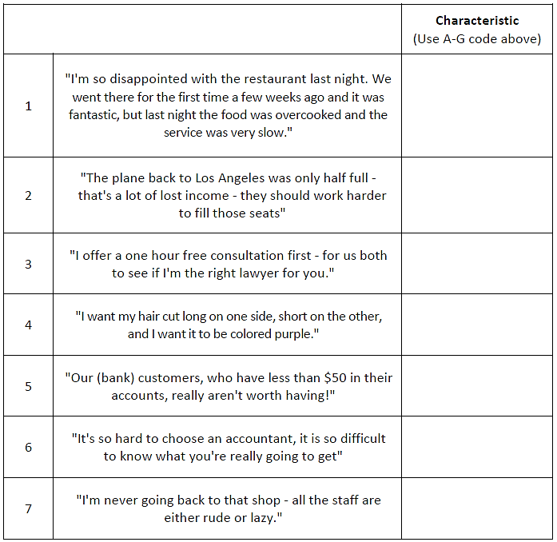
Talk Benefits, Not Features

Consumers buy a product solution (the benefits) for their need/problem. The product's
features and functions are mainly the means to provide the benefits. Therefore, it is
important to communicate benefits - not features - when communicating to customers.

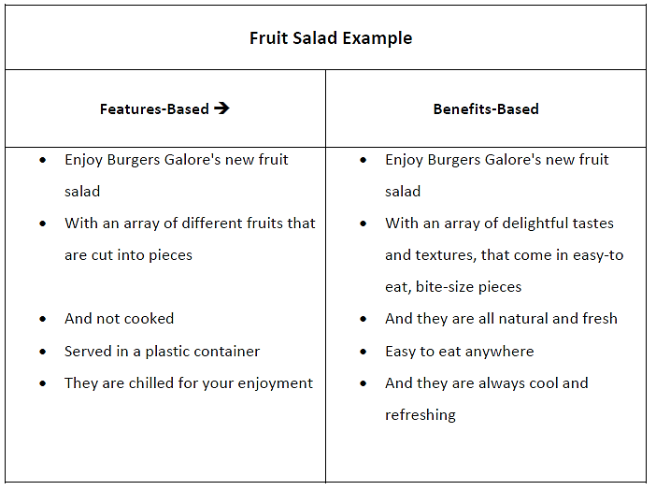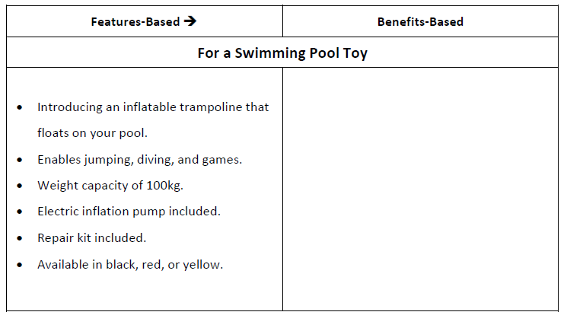

Why New Products Fail?

A high proportion of new products fail. This is surprising when you consider that usually a team of professional managers has evaluated the new product's likely success prior to its introduction and then worked hard on trying to make it successful.
So why do new products fail? The answers are outlined below in a discussion between
various managers.
Part A: Your initial task is to identify the reasons why new products fail. Feel free to add to the list/comments below.
Part B: Determine which of these factors could NOT be adequately assessed prior
to actually going to market with the new product.

Activity/Task
Steven: New products obviously fail because of poor promotion. It simply gets down to your ability to generate brand awareness and communicate the product's benefits to the target market.
Nicola: But that assumes that you have a product that provides benefits. If it's a product that doesn't meet market needs, then it doesn't matter how well it's promoted.
Joanna: It's fine to have a product that meets market needs, but it also has to be better than what competitors are already offering.
Eric: So therefore, it all gets down to research- what customers want, what competitors offer, and what's the best way to communicate to them?
Aylene: Doing the research is one thing, interpreting and correctly using the information is another - and that often depends on how "enthusiastic" the CEO is about the product. I've seen some poor products pushed to market just because they were the CEO's idea.
Katie: And it depends on how customer-focused the firm is. Some firms are very R+D driven, constantly improving technology and adding more product features - sometimes it works, and sometimes it doesn't.
Jessica: Well adding to that point, doesn't a firm always need a strong technology base? I mean they need to have strong technical expertise in a product before they can really compete.
Jeanie: Well I think that technical skill is only part of the puzzle. Once we've made the product, we still need to get access to retailers or a customer base in order to get reasonable sales.
Marshall: Sure there are some basic requirements, but a large firm with lots of financial backing and a strong brand can surpass those obstacles quite easily and virtually enter any market.
Maria: That's right, it's all about financial strength in the marketplace. If you have enough money, you can make any product successful.
Thomas: I don't think it's that simple. I think that market timing has a lot to do with it - just be first-to-market and your new product will be a winner.
Ron: There are significant "responsibilities" in being first to market – building product knowledge, educating customers, and getting retailers on board. I think many firms wouldn't want to be first to market.

Reasons why new products may fail  (PART A) | Are these predictable factors before launch? Y/N (PART B)

New Product Phases

Most new product developments follow a similar series of phases. Your task in this
activity is to simply match the phase to its appropriate definition.

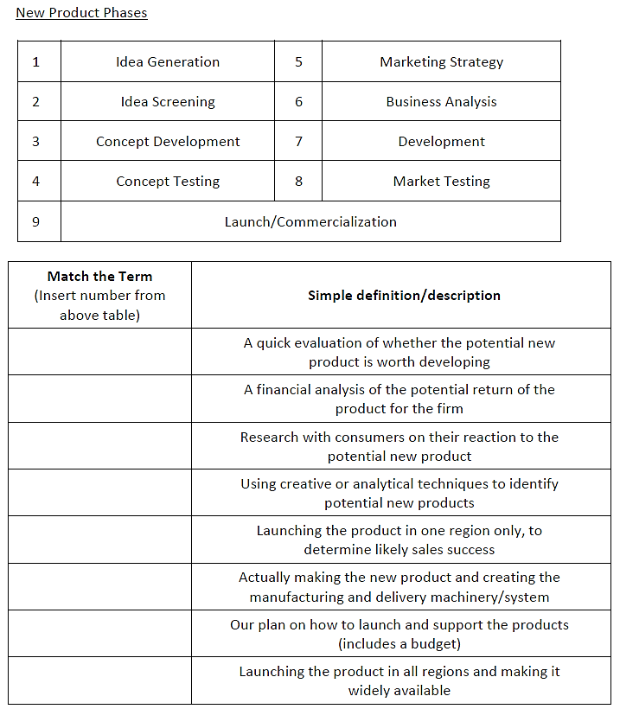

Product Life Cycle (PLC)

Part A: For the first part of this activity you simply need to draw the PLC curve
and label its stages in the space below.
Part B: You then need to plot the products listed below onto your curve, based
upon your general knowledge.

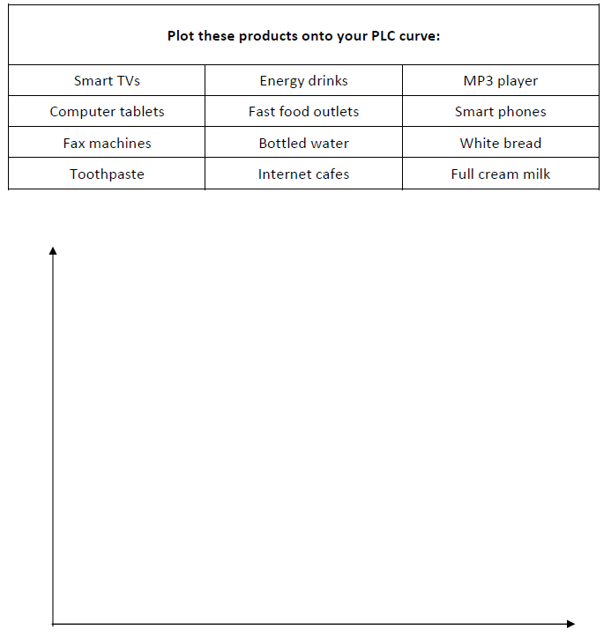

Product Factors Influencing Speed of Adoption
Analyze the following product features and evaluate to what extent this product would be adopted quickly (adoption rate) based on 5 new product characteristics
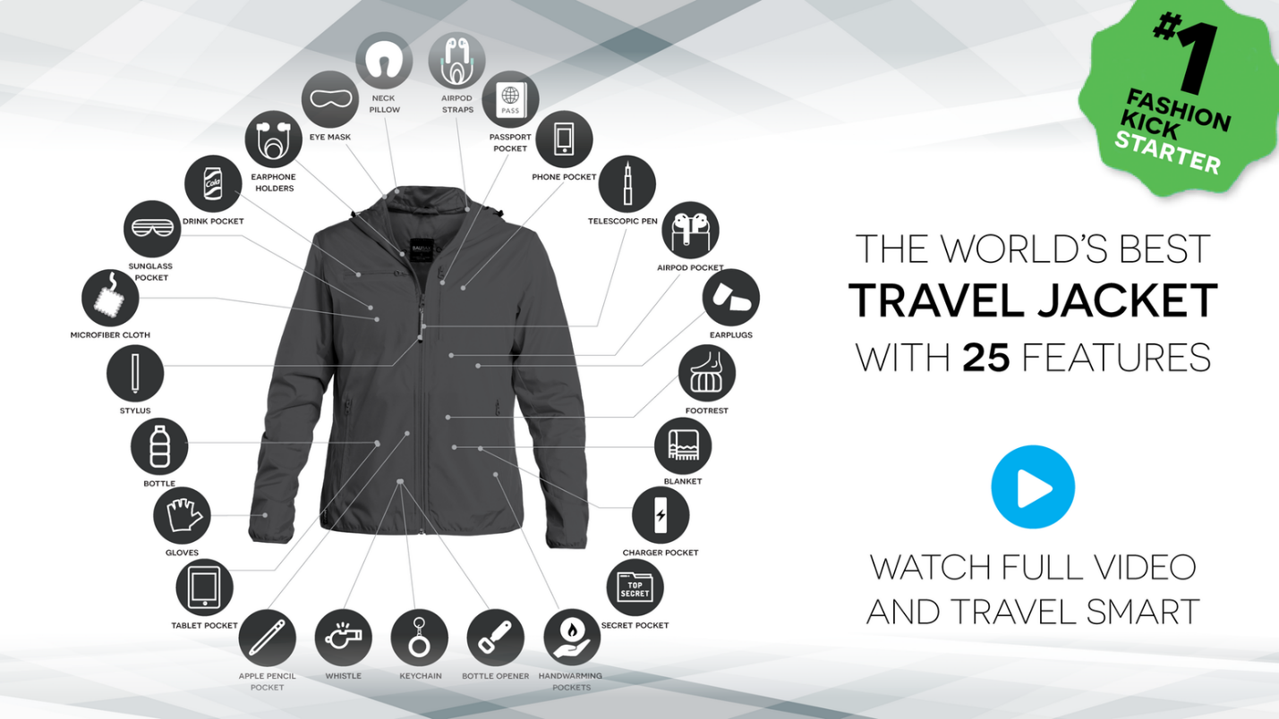
Characteristics | Evaluate how each characteristics of the jacket affect the adoption rate
Relative advantage (Do the new product complete the required task in a superior manner? )
Communicability (Can the brand easily communicate such superiority? )
Compatibility
(Was the product compatible with existing lifestyles?)
Trailability
(Could consumers easily trial the product?)
Complexity
(Was the new product complex to use (for first-time users)?
Cost (Was the product expensive to purchase and maintain? )

Product Factors Influencing Speed of Adoption

Complete the table on the next page (from your general knowledge) regarding the
relative advantages of these two new products.

